

**FACULTY OF SOCIAL SCIENCES**

**DEPARTMENT OF POLITICS AND PUBLIC MANAGEMENT**

THE ROLE OF MEDIA IN ZANU PF’s FACTIONALISM DURING THE PERIOD

2014 - 2015

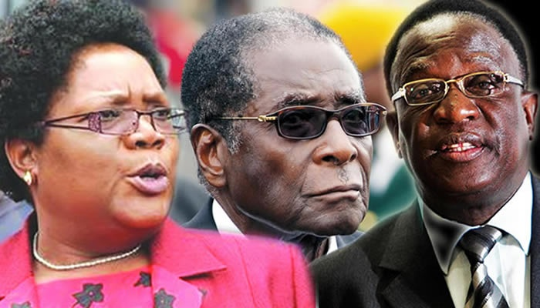

Image Source @www.pindula.com

***A RESEARCH THESIS SUBMITTED IN PARTIAL FULFILMENT OF THE REQUIREMENTS FOR THE BACHELOR OF SOCIAL SCIENCES HONOURS DEGREE IN POLITICS AND PUBLIC MANAGEMENT***

***By***

***PHENEAS MUNEZI (R115376R)***

## RELEASE FORM

NAME OF AUTHOR

Pheneas Munezi

DISSERTATION TITLE

The role of media in ZANU PF’s factionalism during the period 2014 - 2015

DEGREE PROGRAMME

HPPM - Bachelor of Science in Politics and Public Management Honors Degree

YEAR GRANTED

2015

Permission is hereby approved to the Midlands State University Library to generate copies of this research project and or borrow the copy for this dissertation for personal, academic, scholarly or for related research purposes. Any other duplication without the author’s permission is strictly prohibited only.

SIGNED : ………………………………………

PERMANENT ADDRESS : 8748 GLEN NORAH C, HARARE

PHONE NUMBER : +263 776 92 53 26

# Declaration

I the undersigned do hereby proclaim that this dissertation is a product of my own hands and the research findings and investigations have not been offered anywhere else to serve any purpose. Other related sources of information that the researcher has made use of has been fully acknowledged by means of referencing.

PHENEAS MUNEZI

...............................................................................

Date.................................................

## APPROVAL FORM

**FACULTY OF SOCIAL SCIENCES**

The undersigned certify that they have read and recommend to the Midlands State University for acceptance of a dissertation entitled: The role of media in Zanu Pf’s factionalism during the period 2014 - 2015

**SUBMITTED BY: PHENEAS MUNEZI (R115376R)** in partial fulfillment of the requirements for the BSc Honors Degree of Science in Politics and Public Management

SUPERVISOR ..................................................................

Mr S .Moyo

CHAIRPERSON ..................................................................

Mr. P. S Chigora

DATE ..................................................................

## DEDICATION

I do dedicate this work through the support of my parents Mr and Mrs Munezi, and to my friends also with special dedication to my daughter Nenyasha.

## ACKNOWLEDGEMENTS

Special mention goes to my supervisor Mr Moyo for the assistance provided during the course of the study. I do extend my gratitude to the Midlands Provincial Office of Zanu Pf ,ZimPapers , The Zimbabwe Republic Police and the supporters of the Zanu Pf party in the Midlands Province

I would like to take this opportunity again to thank my parents Mrs and Mrs Munezi for the moral and financial support I received from them.

Above all hats-off to God Almighty who granted me the wisdom and grace throughout the entire research.

Table of Contents

RELEASE FORM 2

Declaration 3

APPROVAL FORM 4

DEDICATION 5

ACKNOWLEDGEMENTS 6

Abstract 11

INTRODUCTION 12

Rationale and Background of study 13

Main events prior to the 6th National People Conference 14

Votes of No Confidence 14

Top party official abscond the Politburo 14

Meet the people rallies 15

Harare province 08 October 2014 15

Manicaland Province 10 October 2014 16

Matabeleland South 13 October 2014 16

Bulawayo Province. 15 October 2014 17

Mashonaland Central Province. 16 October 2014 17

Mashonaland East Province 17 October 2014 18

Amendment of the Constitution 18

Congress Theme 18

Events at the Congress 19

New Look Politburo 20

Zanu PF’s Ideology 21

THEORETICAL FRAMEWORK 21

Influence of Media on Social Behavior 21

Social Cognitive Theory of Mass Communication (Albert Bandura) 22

PARTY POLITICS AND FACTIONALISM 22

Aims of the study 23

Objectives of the study 23

Statement of the problem 23

Significance of study 24

Research Questions 24

Justification of the Study 24

Research methodology 24

Research Approach 24

Data Collection and Research Design 25

Literature Review 26

Media Development 26

Defining Social Media 26

Whatsapp 26

Press and Television 26

MEDIA AND POLITICS 27

1. Social Media as an organizational tool 27

2. Social Media as an alternative press 28

3. Social Media as generating awareness 28

FREEDOM OF MEDIA AND MEDIA LAWS 29

MEDIA LAWS (Geoff Feltoe) 30

Bibliography 32

PRELIMINARY CHAPTER 34

Stages of factionalism 34

Stage 1: Dissent 35

Stage 2:Intraparty Conflict 35

Stage 3: Departure 35

CHAPTER ONE 36

STAGE 1: DISSENTS 36

The Role of Media in the Manifestation and Nurturing of Dissents in Zanu PF 36

Three face party model 36

Media versus Three Faces of Zanu Pf 38

Unregulated and uncensored social networking and implications 39

News and implications about “Zanu PF on the ground” and “Zanu PF in central office” 40

Robert Mugabe’s Capacity to lead 40

Robert Mugabe’s control over Zanu PF 41

Zanu PF’s weakness 42

Robert Mugabe on Kamuzu Moments 43

CHAPTER TWO 45

THE ROLE OF MEDIA IN THE ZANU PF’S INTRA PARTY CONFLICT 45

STAGE 2: INTRA-PARTY CONFLICT 45

The role of media in the Zanu PF’s intra elite and follower conflict 45

Social media 45

Voice 48

Press release 49

CHAPTER THREE 55

THE ROLE OF MEDIA IN THE DEPARTURE AND SUSPENSION OF ZANU PF PARTY MEMBERS 55

STAGE 3: EXIT 55

Leader’s response 55

Media and the concept of Appearance and Reality 56

Research findings and conclusion 58

Conclusion 61

BIBLIOGRAPHY 63

APPENDICES 66

Interview Schedule 66

DATA COLLECTION LETTER 71

**LIST OF ACRONYMS**

AIPPA : Access to Information Privacy Protect Act

MDC : Movement for Democratic Change

POSA : Public Order Security Act

ZANLA : Zimbabwe African National Liberation Army

ZAPU : Zimbabwe African People’s Union

ZANU-PF: Zimbabwe African National Union – Patriotic Front

ZBC : Zimbabwe Broadcasting Cooperation

SMN : Social Media Networking

ICT : Information Communication Technology

## Abstract

This research was an analysis of the role of media in the Zanu Pf”s factionalism that occurred in the year 2014 to 2015. An extraction of the role played by the media in the stages of factionalism and how the prescribed laws and regulatory measures failed to control and avert political uncertainty in the party and the country at large . Theories were the support base of the thesis. Qualitative research method was used to gather information with the use of secondary and primary sources. The researcher made use of interviews, archival sources and focused group discussion in gathering data from selected population sample. The target population comprised of the Zanu Pf party and its various stakeholders, The Media House and The Zimbabwe Republic Police in the Midlands Province. About 15 interviews were administered. The researcher was necessary, he had to use the native language thus shone to assist in the interpretation of questions. The data gathered from the field was presented by the use of theoretical models that that explains the stages of factionalism. The data gathered shows that the media played both constructive and destructive role in the Zanu Pf fiasco. As a result the researcher had to give recommendations on what has to be done to redress the loopholes in the Zimbabwean Information and Technology system to avert future political hiccups fueled by the media.

## INTRODUCTION

*One of the objectives of a newspaper is to understand the popular feeling and give expression to it; another is to arouse among the people certain desirable sentiments; the third is fearlessly to expose popular defects. (Mahatma Gandhi)*

This thesis examines the role played by media in the political unrest and revelation within the Zimbabwe African National Union –Patriotic Front (ZANU PF) party which occurred in the year 2014 to 2015. This study will seek to interrogate the extent to which the media is responsible for the political uncertainty and factionalism which stunned the ZANU PF political party. Using the case of ZANU PF factionalism, this thesis will argue and prove Elizabeth Relms argument that:

*“The power of media in warfare is formidable. It can be a mediator or an interpreter or even a facilitator of conflict. If only by editing away facts that do not fit the demands of air time or print space, many wars would be avoided”.*

Diplomacy has evolved over the years as a concept deemed to avert and counter conflict just as much as the media has evolved to generate and assist conflict which makes the hard work of diplomacy a wild goose chase. This thesis will vividly explain and expose how the media can and will always play a crucial role in the factionalism of political parties regardless of the so called “media laws, regulations and ethics”

Factionalism in the Zimbabwean ruling party ZANU PF will be used as a case study for the basis of the argument. The case study happened prior to the party’s national congress in this regard the target population for the study are the ZANU PF party’s stakeholders which includes, Zanu Pf political party members, political scientists, media houses and the Zimbabwe Republic Police. In this regard the researcher will use archival research method, interviews and group discussions as the method of collecting relevant data for analysis.

## Rationale and Background of study

In 1974, the major African patriotic groups namely, the Zimbabwe African Peoples Union (ZAPU) and the Zimbabwe African National Union (ZANU consolidated their military powers giving birth to a political party namely ZANU PF, a formidable political entity with national interest and black empowerment at heart, headed by Robert Gabriel Mugabe.

Trouble in paradise commenced in the 6th term of Zanu PF in power, still under Robert Gabriel Mugabe, friction was to the Mugabe’s successor. Joyce Mujuru and Emerson Mnangagwa imaged to be the major contestants in the fight to succeed a 91 year old Mugabe, who is believed, should announce his retirement plans possibly before the end of his fresh five year term in 2018.

Reportedly they were two main factions within the party, led by Mujuru and another by Mnangagwa garnering to replace Mugabe. The rift between the warring factions widened during Grace Mugabe's “Meet the People” rallies which saw the first lady embarking on a countrywide campaign denouncing factional leaders. The rallies took place during the month of October in 2014 and were followed by dismissals, suspensions and expulsions of party members believed to be linked to Vice President Mujuru. The First Lady embarked on her tours after she was propelled to lead the Women's League and her tours were poised on exposing the rot and or rogue elements within the party, a process which she likened as to the process of removing evil spirits which were brooding within the party.

## Main events prior to the 6th National People Conference

## Votes of No Confidence

Following accusations and counter accusations of fanning factionalism and playing divisive politics, the Zanu PF party saw a wave of “votes of no confidence” which claimed the scalps of political heavyweights such as John Mvundura, Kalisto Gwanetsa, Ray Kaukonde and Temba Mliswa among other provincial chairs that were dismissed from the party. Other party members such as Amos Midzi were also dismissed from the party alongside their functionaries who were all being accused of fanning factionalism. Although several individuals like Gwanetsa and Mliswa were said to have been working round the clock to reverse their ouster, the party upheld the decision by their provinces to remove them from their posts.

## Top party official abscond the Politburo

Having been publicly challenged to deny allegations made against her which included cases of corruption, extortion and dubious business transactions, Joyce Mujuru was said to have skipped two consecutive politburo meetings. The failure to attend the meeting was interpreted in heavily contrasting manners with some claiming that she had accepted her inevitable demise while others went on to claim that she was scared for her life and others claiming that she was scared to face the music. Goche who was also implicated in the plot to assassinate Robert Mugabe also failed to attend the meeting after he was said to be very sick as he was admitted into the intensive care unit of a local hospital. In an equally interesting and related matter, it was alleged that Flora Buka who was also linked to the Mujuru camp had collapsed following two successive defeats in the Women's league and Central Committee respectively.

## Meet the people rallies

## Harare province 08 October 2014

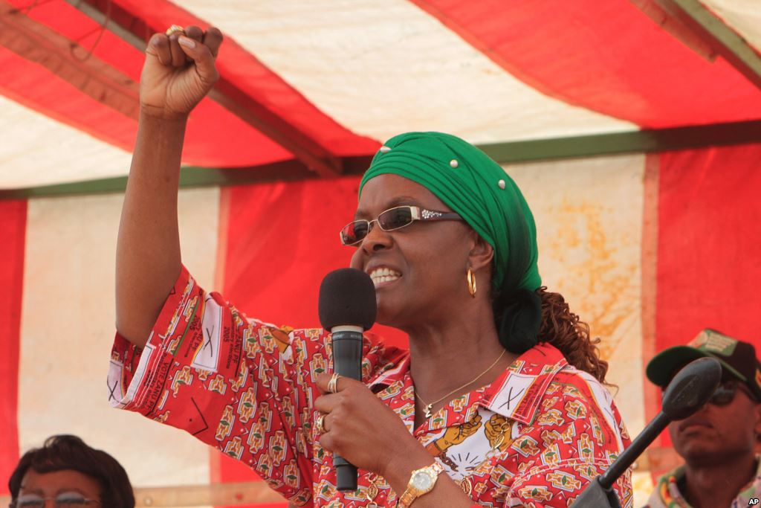

Image source @ [www.pindula.com](http://www.pindula.com)

Grace Mugabe kicked off her official duty as the first secretary of the Women's League by meeting the party supporters for Harare province at the City Sports Centre. The first lady was accompanied by Oppah Muchinguri and Eunice Moyo a member of the Politburo. The main highlight of her speech at this meeting was her call against factionalism in the party. In an effort to effectively convey her message, Grace made a physical gesture by calling two alleged faction leaders to unite in the spirit of togetherness including Amos Midzi who is the provincial party chairman and Godwin Gomwe the provincial youth leader.

## Manicaland Province 10 October 2014

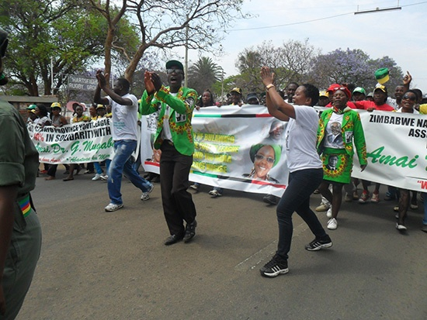

Image source @ www.pindula.com

The Manicaland rally took place at Sakubva stadium in Mutare. There were reports of violence as youths clashed due to factional differences. A group of youths accused a fellow youth leader Godwin Gomwe for humiliating the “provincial godfather” Didymus Mutasa and accusing him for agitating factional differences within the party. Grace Mugabe showed utter disappointment as she launched a verbal attack on the people who were using Robert Mugabe's name to achieve their individual political ends.

## Matabeleland South 13 October 2014

The rally was held in Gwanda at Pelandaba Stadium. Grace Mugabe began by briefing the party' provincial leadership before proceeding to “meet the people”. Phillip Chiyangwa, Simon KhayaMoyo, ObertMpofu, Temba Mliswa and Patrick Zhuwao were some of the figures who attended the rally.

## Bulawayo Province. 15 October 2014

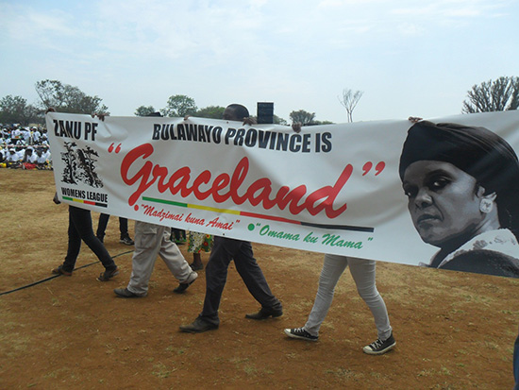

Image source @ www.pindula.com

The rally was held at Amazulu Sports Club. In a feat of disappointment or disapproval, some people decided to march out of the rally while the first lady was busy with her address. Responding to the humiliating demonstration of impatience by the women who were marching out, the first lady burst into anxiety and she was quoted saying ,“You are disorganized, Bulawayo, this is disrespectful, We are about to finish, Sit down, where are those women going? Anyone who doesn’t sit down will not receive the farming inputs I brought”. Considering the unpopularity of the Zanu Pf party in the Matabeleland region, it can be argued that the women who walked out were indeed showing their dislike for the party in general and Grace Mugabe in particular.

## Mashonaland Central Province. 16 October 2014

The Mash Central Meet the People episode took place at Chipadze Stadium in Bindura which is the capital of Mashonaland Central Province. The first lady went toured the province in the company of government officials and ministers including Jonathan Moyo, Supa Mandiwanzira and Saviour Kasukuwere. In her speech, she tackled the issue of factions when she proclaimed that she was going to deal with one faction leader who became to be known as “gamatox”. There was widespread speculation in the media that “gamatox” was a name used to refer to Didymus Mutasa who was linked to the faction led by Vice President Joice Mujuru.

## Mashonaland East Province 17 October 2014

Rudhaka Stadium in Marondera became a theatre of drama when the first lady toured Mashonaland East Province in her meet the people rallies. She openly accused the Zanu PF provincial chairman Ray Kaukonde of siding with Joyce Mujuru faction in a bid to remove Robert Mugabe from power. Her speech was all over the media due to its explicit nature and it was construed as having “undressed” Ray Kaukonde. She also took a swipe at the Mashonaland east provincial youth chairperson for not being part of her meet the people rallies. The Mashonaland East rally attracted attention from various circles as it took a more direct approach to the factional fights which have marred the revolutionary party. Some of the attendants included Joseph Chinotimba and Ignatius Chombo.

## Amendment of the Constitution

The constitution of the party was amended during the build up to the 6th National Congress which saw the president being given powers to appoint two deputies of his own choice. The politburo sat on November 18, 2014 which saw the body effecting changes on the party's constitution

## Congress Theme

Accelerated Implementation of ZimAsset.

## Events at the Congress

Events prior to the holding of the congress had already set the tone for what was most likely to happen at the congress. Individuals that had been fingered as part of a group plotting to remove President Robert Mugabe from office illegally. The individuals such as Joyce Mujuru and Ray Kaukonde were not present at the event with certain members of the youth league arguing that if any of the members of the group accused of intending to unseat Robert Mugabe dared to show up, things would turn violent. Although Webster Shamu and Dzikamai Mavhaire were part of the accused, they attended the congress but were said to be very isolated.

Regardless the fact that ZANU PF youths and the war veterans had declared war on those aligned to the Mujuru faction if they dared to show up at the Congress, on the third day of the congress, Mugabe used it as evidence to argue that Mujuru was a thief as her absence was a typical fashion of a thief. Mugabe also stated that Mujuru stole diamonds and gold and she also accused him of plotting to unseat him. He also praised his wife for playing a critical role in routing rogue elements within the party, hinting their demise if found guilty. Mugabe was reinforcing what he had said a day before the commencement of the congress when he addressed party youths and war veterans who gathered at the party's headquarters. This happened after the congress as those aligned to Mujuru were sucked.

## New Look Politburo

|  |  |
| --- | --- |
| **Name** | **Designation** |
| Robert Mugabe | President & 1st Secretary |
| Phelekezela Mphoko | Vice President & 2nd Secretary |
| Emerson Mnangagwa | Vice President & 2nd Secretary |
| Ignatius Chombo | Secretary for Administration |
| Saviour Kasukuwere | Secretary for the Commissariat |
| Obert Mpofu | Secretary for Finance |
| Simbarashe Mumbengegwi | External Affairs |
| KemboMohadi | National Security |
| OppahMuchinguri | Transport and Social Welfare |
| Simon KhayaMoyo | Information and Publicity |
| Patrick Chinamasa | Legal Affairs |
| Mike Bimha | Implementation Economic Empowerment Policy |
| Josiah Hungwe | Production and Labour |
| Cleveria Chizema | Health and Child welfare & the Elderly |
| Christopher Mushohwe | Economic Affairs |
| Dr Grace Mugabe | Women’s Affairs |
| PupuraiTogarepi | Youth Affairs |
| Joram Gumbo | Education |
| ThokozileMathuthu | Gender and Culture |
| Joshua Malinga | Disabled |
| Cain Mathema | Land Reform and Resettlement |
| Prof. Jonathan Moyo | Science and Tech |
| SithembisoNyoni | Business Development |
| PriscaMupfumira | Environment and Tourism |
| Sydney Sekeramayi | War Veterans |
|  |  |

## Zanu PF’s Ideology

Zanu PF embraced the doctrine of socialism during the height of the liberation struggle which also explains the military assistance extended to the country by countries such as Russia, China and Yugoslavia. Ideologically, socialism has been the trump card of Zanu PF since the days of the liberation struggle.

## THEORETICAL FRAMEWORK

## Influence of Media on Social Behavior

As new forms of media evolve, new questions are posed as to their effect on social behavior (Meyrowitz 1985).

In addition, Chouliaraki discusses the role of media contents and notes that the media makes spectators feel that they operate generously on their own and are endowed with spontaneous civic or humanitarian feelings that makes them react. In other words the media when used unethically can be used to create an uprising against the government or various authorities.

Joshua Meyrowitz in his analysis of the impact of media on social situations ‘also notes that exposure to the media can alter the receivers perception. This, he says, is created by an amalgamation of the personal and public spheres hence there is no clear separation of the two spheres in an individual‘s internal process of thinking and decision making. In other words as a result of this merge, an audience watching a video clip of the government spokesperson justifying banning the media, find himself (personal sphere) in touch with the war”tension (public sphere) that is ongoing in the government offices and media houses. The resultant amalgamation is the action of agreement or revolting, demonstrating or fighting.

## Social Cognitive Theory of Mass Communication (Albert Bandura)

Social cognitive theory provides a conceptual framework within which to analyze the determinants and psychosocial mechanisms through which symbolic communication influences human thought, affect and action. Communications systems operate through two pathways. In the direct pathway, they promote changes by informing, enabling, motivating, and guiding participants. In the socially mediated pathway, media influences link participants to social networks and community settings that provide natural incentives and continued personalized guidance, for desired change. Social cognitive theory analyses social diffusion of new styles of behavior in terms of the psychosocial factors governing their acquisition and adoption and the social networks through which they spread and are supported. Structural interconnectedness provides potential diffusion paths, socio-cognitive factors largely determine what diffuses through those paths

## PARTY POLITICS AND FACTIONALISM

Using the case study of the indigenous communication practices of Jemez Pueblo, Littlefield, Robert S, Ball, and Jane, in their journal “factionalism as argumentation” expressed the concept of factionalism as a process. Accordingly, the process of factionalism is nurtured by different aspects of politics, society and the economy, however most of all there is the media as the center piece on the factionalism chess board .In the words of ball, this grouping, of factionalism, is divided into six stages namely :

1. The identification of the issue
2. The talking of sides
3. The presentation of the arguments
4. The decision of the authority figure
5. The recognition of the need for symbolic healing
6. The haling and resolution

## Aims of the study

The purpose of this research is to expose the role played by the media in political instability with reference to the case of Zanu pf’s factionalism, this thesis examines the influence and impact of media on politics and human security, regardless the existence of the prescribed legal frameworks to tame media practices

## Objectives of the study

1. To analyze the impact and effect of media on human behavior
2. To establish the relevance of media in managing political stability and instability
3. To establish the benefits and dangers of media on politics
4. To unearth the role of media in the stages of factionalism?
5. To make recommendations if they are any

## Statement of the problem

Unanalyzed, uncensored and barely regulated media practices in Zimbabwe triggers political uncertainty and civil disobedience. Unanalyzed political content circulating around social networks and other forms of media in relation to the factionalism of Zane puff has intensified the conflict between the two alleged factions led by the Former Vice President J .Majuro and the current Zimbabwean Vice President Emerson Mnangagwa.

The media played a role in the Zanu Pf factionalism through de-campaigning politicians, discrediting integrity, questioning their competence and allegiance to the party. Media disregards to the concept of appearance and reality misinforms the nation.

## Significance of study

The research will seek to provide a vivid examination and analysis of the role of media in political instability in Zimbabwe and the ineffectiveness of the prescribed media laws and regulations formulated to avert the wrath of media on human security. The research will also be of great relevance academically and in the formulation of public policies in relation to media practices.

## Research Questions

1. What are the impacts and effects of media on human behavior
2. How relevant is the media in managing political stability and instability
3. What are the benefits and dangers of media on politics
4. What is the role of media in the stages of factionalism?

## Justification of the Study

The continued development of media against ineffective laws and regulations is reinforcing the negative influence and impact of media on politics and human security. Using the factionalism of Zanu Pf, this thesis exposes the role of media in political conflict and proposes recommendations to manage media influence on politics and human security.

## Research methodology

## Research Approach

The researcher is going to make use of the qualitative research design which is defined by Rukuni (2000) quoted by McCleod as “a process of systematic enquiry into the meanings which people employ to make sense of their experiences and guide their actions”. The research seeks to extract the role played by media, in this regard the argument will be supported by media content obtained from all relevant media forms in order to present adequate evidence for the basis of the argument therefore the research will mainly depend on archival research approach which Lentz (2012) described as the analysis of fellow researchers' studies or utilization of historical or modern media records.

## Data Collection and Research Design

The research will make use of primary sources of data which will be acquired through interviews and focus group discussions. The researcher will interview different informants from various Zanu pf stakeholders. Importantly, interviews gives first hand information from the source as the researcher would ask for further clarifications. Under focus group discussions as a data gathering tool Millward L and Breakwell G (2012) defines it as “a discussion based interview that produces verbal data generated via group interaction.” In this case the focus group discussions will be used analyze data and extract information, however the research will mainly base its argument on secondary source since it provides reliable evidence and tangible content for analysis.

Secondary sources will be the sole source of data in this research; they will come in the form of published data such as academic articles, newspaper, personalized images, Whatsapp media content and videos. Secondary sources strengthens the argument because it provides the actual content that is responsible for the nature of behavior displayed by the audience in relation to the fiasco of Zanu pf and it gives tangible evidence for analysis.

## Literature Review

*“The power of media in warfare is formidable. It can be a mediator or an interpreter or even a facilitator of conflict. If only by editing away facts that do not fit the demands of air time or print space, many wars would be avoided,”*

*Elizabeth Relms*

## Media Development

## Defining Social Media

Social media networks (SMNs), a subcategory of ICTs, are defined as “online tools and utilities that allow communication of information online, participation and collaboration.” This also includes websites that “interact with the users, while giving them information. Facebook and Whatsapp Messenger are two most widely used SMNs in the fiasco of Zanu PF factionalism.

## Whatsapp

Whatsapp messenger is a social network that uses the internet to share text messages, pictures, audio and videos from one user to another or a group chat .The application can be installed on users mobile devices with a compatible operating system and model version .This is a fast growing social network in Zimbabwe with more than 4 million users in the country.

## Press and Television

In Zimbabwe the print sector is very much diverse in terms of ownership ,there is the state owned newspaper group (ZimPapers) and the privately owned press by Alpha Media Holdings .The state owns dominant giant papers titled ,The Herald ,Sunday Mail as well as regional papers like the Chronicles ,Sunday times as well as Manica post in Mutare .The state also owns three tabloids titled Kwayedza ,H Metro and B Metro .On the other hand the Alpha Media Holdings owns papers like Newsday ,Southern Eye and Political financial weekly Zimbabwe independent. The television is also owned by the Zimbabwe broadcasting holdings, a state owned entity.

## MEDIA AND POLITICS

An unpublished scholar Madeline Storck in his thesis on the Role of Social Media in Political Mobilization (Case Study of the January 2011 Egyptian Uprising), categorized the relationship between politics and media into three identifiable trends: social media as an organizational tool, as an alternative press and outlet for citizen journalism, and finally as a tool for generating awareness both regionally and internationally.

## 1. Social Media as an organizational tool

In comparison with the Tunisian and Libyan uprising which took 28 days and roughly nine (9) months respectively to succeed, stork believed that the Egyptian uprising was unique in terms of speed and coordination because of the massive help of social media, the Egyptian activists unseated Mubarak in a mere eighteen (18) days, and again, relatively peacefully in comparison to other uprisings in the Arab Spring.

The efficient use of social networks as a form of organizational infrastructure was at the Centre of events acceleration that began with virtual networks and was transposed to offline networks. Egyptian protestors were able to successfully play off the strengths of the social networking capabilities of Facebook and Twitter by capitalizing on their “many to many” communication capabilities and the speed with which information can be transferred and spread, an inherent characteristic to any digital media.

## 2. Social Media as an alternative press

With its low entry barriers, social media tools provide an accessible platform for citizen journalism, defined as the use of digital media tools to “report on events on the ground, uploading text and videos directly to the Internet or feeding the information and videos to media outlets.” The dialogue taking place via Facebook, twitter and other SMNs was used by the mainstream media as a source during the height of the protests. Aljazeera in particular relied on reputed bloggers and Twitter users during the uprisings for real time coverage of events, by using Sharek, a citizen’s media platform that received and filtered through submissions by citizen journalists.

## 3. Social Media as generating awareness

Much attention has been paid to the role that the Internet has played in generating awareness of the Arab Spring in both the Middle east and internationally. This is another example of how movements started online were transposed to offline movements where they gained momentum and attention. A poll by the Arab Social Media Report indicated that in Egypt, the majority of Facebook users polled agreed that Facebook was used most effectively to raise awareness of the causes of the movements within the country. The best example of this is the creation of the Facebook group We Are All Khaled Said by Google executive WaelGhonim. Created to commemorate the brutal murder of the young Egyptian blogger who died at the hands of police, the Facebook group quickly attracted over 500,000 members who spread the graphic

## FREEDOM OF MEDIA AND MEDIA LAWS

Norris and Zinnbauer’s (2002) thesis follows the freedom of press argument, and they find that an independent press is strongly associated with good governance and human development. In particular, nations with a free press are characterized by less corruption, greater administrative efficiency, a politically stable environment, effective rule of law and better economic development in general. Bandyopadhyay (2009) finds that mass media and information communication penetration is associated with lower levels of corruption and poverty. Dutta, Pal and Roy (2011) find that a free and independent media acts as a means of enhancing socio-political stability which in turn leads to higher economic growth via increased domestic investment. Freille, Haque and Kneller (2007) find evidence that both political and economic influences on the media are robustly related to corruption, while detrimental laws and regulations influencing the media are not. Gusevaetal (2008) emphasize the role of a free press in economic development. Kaufmann (2006) recognizes the key role of media as a part of the good governance, anticorruption, and poverty alleviation endeavors of international organizations, especially the World Bank. He also emphasizes the need to popularize other measures of media development in mainstream academic literature to expand and improve analysis. Norris (2010) emphasizes the need to recognize media as an integral part of the core institutional framework that empowers democracy.

A third way that a free media is theorized to promote socio-political stability is that an uncensored media has greater ability to disseminate news internationally. This international flow of information may help create external pressure on governments to act less in their own interests and more in the interests of their citizens. For example, there was little international outcry in the early 1970s when several Sub-Saharan African governments did little in the face of devastating famines. Sen (2000) connects the lack of international outcry to a lack of media freedom, and thus the lack of information flowing out of these countries.

## MEDIA LAWS (Geoff Feltoe)

Media in Zimbabwe is regulated by different laws and regulations in both the print and electronic media operate under clear stipulated legal frameworks. There is no specific constitutional guarantee of access to information held by government departments. However in terms of the Access to Information and Protection of Privacy Act [Chapter 10)27] the media has a right to obtain access to various types of information held by public bodies. Only a journalist who is accredited has the right to seek access to information held by public bodies.

There are, however, various types of information that either must not be disclosed or in respect of which the head of the public body has discretion whether or not to disclose. These include:

* Deliberations of Cabinet and local government bodies [s 14]
* Information whose disclosure will be harmful to law enforcement process and national security [s 17]
* Information relating to personal safety [s 22]
* Information relating to business interests of a third party [s 24]
* Information relating to personal privacy [s 28].

There is no specific guarantee of freedom of the press in the Zimbabwean Constitution. By contrast, Article 21(1) (a) of Namibia’s Constitution which guarantees freedom of speech and expression makes explicit reference to the freedom of the press and other media. Similarly the freedom of the press and other media is expressly guaranteed in Article 16 of the South African Constitution.

In the Zimbabwean Constitution s 20 lays down that everyone has the right to enjoy freedom of expression, that is to say, freedom to hold opinions and to receive and impart ideas and information without interference. There is no explicit provision on freedom of the press. However, the general provision on freedom of expression encompasses freedom of expression by the press.

The Zimbabwe Supreme Court has repeatedly emphasized the importance of freedom of expression. In various judgments it has said the following things:

Freedom of expression is one of the most precious of all the freedoms and is a vitally important right that is an indispensable condition for a free and democratic society. Without the freedom to express, interchange and communicate new ideas and advance critical opinions about public affairs or the functioning of public institutions, a democracy cannot survive. Freedom of expression is universally recognized as a core value of society. One of the functions of freedom of expression is to protect the free flow of information and ideas in a society. This is essential to the proper functioning of a democratic system. In the political sphere, political parties competing for power are entitled to communicate freely with the electorate in order to try to persuade the electorate to support them and vote for them. Only by the spread of information, opinions and arguments, can voters make a responsible choice in determining whether they should support a particular candidate at an election or the party that person represents.

## Bibliography

Andersen, E.W. and Olsen, R.K. (1996) “Press freedom and democracy in Zimbabwe,” M.Phil.Thesis, Department of Media and Communication, University of Oslo. Andersen, M.B. (1997)

Bandyopadhyay, Sanghamitra (2009), “Knowledge.based economic development) mass media and the weightless economy,” DARP,74. Suntory and Toyota International Centres for Economics and Related Disciplines, London School of Economics and Political Science, London, UK.

Bandura, A. (1986). Social foundations of thought and action) A social.cognitive theory. Englewood Cliffs

Bushman, B. J. &Huesmann, L. R. (2001).Effects of televised violence on aggression.In D. Singer & J.

Djankov, Simeon, CaraleeMcLiesh, Tatiana Nenova, and Andrei Shleifer (2003), “Who Owns the Media?,” Journal of Law and Economics, 46, 341.382.

Meyrowitz, Joshua 1985.No Sense of Place) The Impact of Electronic Media on Social Behavior. New York) Oxford University Press

Mugabe bans 'PasiNegamatox', 'Pasi Ne Zvipfukuto' slogans, Harare 24News, Published) October 31, 2014, Retrieved) march14, 2015

Mujuru loyalists chased away at Mnangagwa bash, Newsday, Published) December 15, 2014, retrieved) March 15, 2015

Melkote, S.R. (1991) Communication for Development in the Third World. Theory and Practice, New Delhi, Newbury Park and London)

Norris, Pippa (2010), “Public Sentinel) News Media & Governance Reform,” World Bank.

Ray Kaukonde flees to SA, The Sunday Mail, and Published) December 7, 2014, Retrieved) January 13, 2015

New Look ZANU PF Politburo, The Financial Gazette, and Published) December 10, 2014, retrieved) March 2015

Rukuni, T. (2000) Qualitative interviewing, the act of hearing data.London) Sage Publications.

Geoff Feltoe, A Guide to Media Law in Zimbabwe. 1 November 2002, Legal Resources Foundation of Zimbabwe, Harare

Kaufmann, Daniel (2006), “Media, Governance and Development,” Keynote Presentation, UNESCO World Press Freedom Day Meeting.

Zanu PF Congress Update) Mujuru a ‘thief’ says Mugabe, Newsday, published) 4 Dec 2104, retrieved) 15 January 2015”

Congress, The Sunday Mail, published) Sat 6 Dec 2014, retrieved) 13 Jan 2015”

## PRELIMINARY CHAPTER

*“the media may not be successful much of the time in telling people what to think, but it is stunningly successful in telling readers what to think about” (Cohen 1963).*

## Stages of factionalism

The researcher uses Splinter party formation to analyze the findings; accordingly, the concept of factionalism is solely reached after all the series of splinter party formation stages are completed. The researcher managed to trace and collect the data of all the events and political activities that breathed life into the concept of factionalism in the Zanu PF party, in this regard the researcher will uncover the position of media in each stage in order to extract its role in the division of Zanu PF

**Fig 4.1 Splinter party formation model**

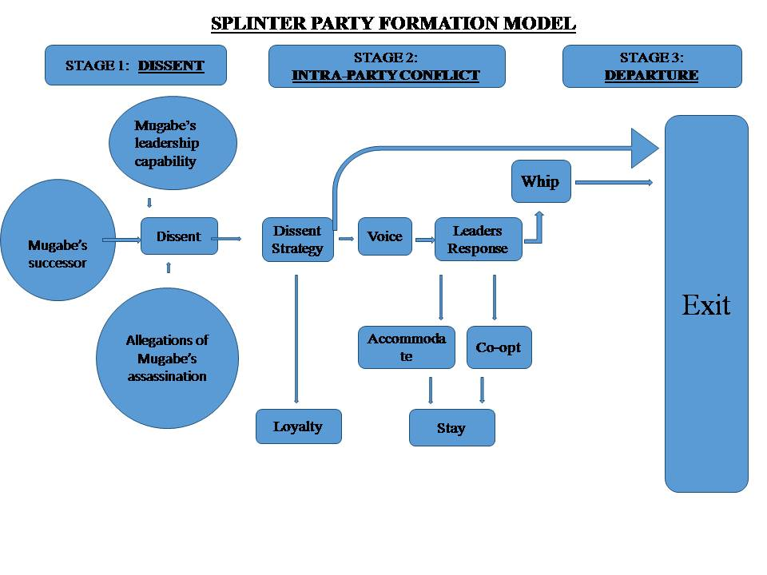

## Stage 1: Dissent

Dissent, is the period during which nonconforming members of the party start to identify issues that disappoint them with the leadership’s scope and strategies of the party.

## Stage 2:Intraparty Conflict

Intraparty conflict is the phase where arguments are presented and dissent is manifested in the form of exit or voice.

## Stage 3: Departure

Departure is the phrase when displeased dissidents decide on their final strategy or the party’s authority figures dismiss the dissidents.

## CHAPTER ONE

## STAGE 1: DISSENTS

The agenda setting theory associated with Shaw and McCombs (1972) explains the strong media effects by suggesting that the media affects the scope of thinking. In essence, through daily reporting over time, the media agenda becomes the public agenda.

## The Role of Media in the Manifestation and Nurturing of Dissents in Zanu PF

Political parties can be defined as any group seeking to elect governmental office holders under a given label, which may or may not be on the ballot (Epstein 1993). In order to achieve this objective, political parties must operate under different faces as explained by Katz and Mair, if they are to survive in power and ensure political stability in the country simultaneously, because most political parties face periods of intraparty conflict and most of these conflicts are resolved within party platforms, unfortunately some of these conflicts are exposed by the media which triggers panicking and friction within the party and loss of confident to the party’s leadership and administration by its stakeholders.

## Three face party model

Katz and Mair explained how the political parties try to maintain and uphold their responsibility and accountability to the public even in the midst of intraparty political hiccups. Accordingly, party organizations have three faces: party in public office, party in central office and the party on the ground. The three faces of party organization enable us to gain an insight into the changing capability of different party organs as shown in fig 4.2.

Fig 4.2

**Three face model**

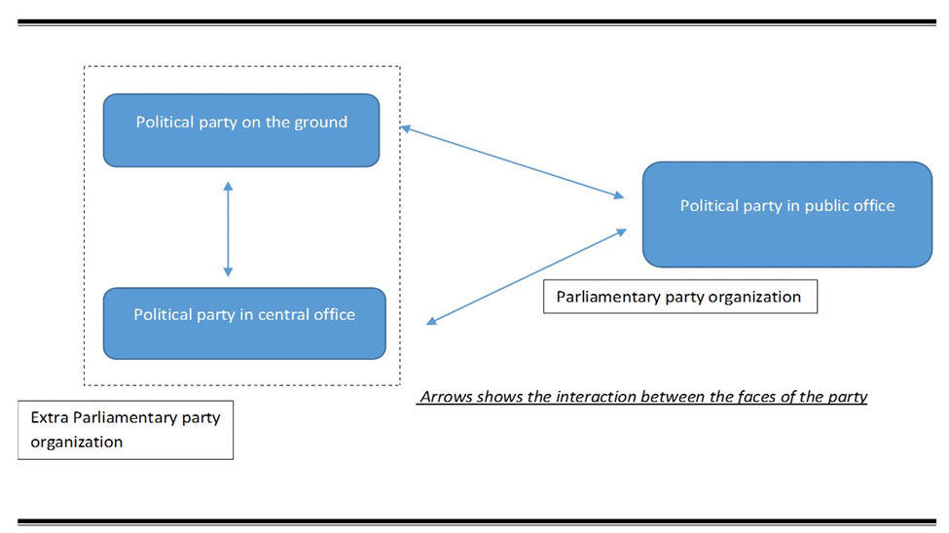

The party in public office refers to the elected members of the party in parliament and in government. It comprises the parliamentary party, known also as parliamentary group, which is crucial for cabinet formation in parliamentary systems.

On the other hand, party in central office and the party on the ground constitute the extra parliamentary party: these parties have to deal with the issues of securing power and managing criticism from opposition parties and civil societies that might impact negatively on the central party’s image.

The party in central office refers to the national leadership of the party organization, whereas the party on the ground represents the rank and file of the party, comprising ordinary party members as well as party activists who play a more extensive role than members at grassroots level

Conservatively, the media treated political parties as an unitary actor, sacrificing state governance and the nature of political parties for analytical gain in the name of quality independent media that present comprehensive information about government and politics, to hold political and business elites to account through critical commentary and investigative reporting, and to provide a forum for a broad range of voices.

## Media versus Three Faces of Zanu Pf

The three faces of political parties works hand in hand in the governance of the state and each face is responsible for its unique obligation that keeps the political party in power ,provide good governance and maintaining a sustainable politically stable environment .

However the media does not recognize or acknowledge the significance of a three party ideal ,what the media is mainly concerned about is to report news as they happen as the Zimbabwe Broadcasting Cooperation’s adage that “when it happens we will be there” and of course the media will be there the question is, will they be there with political scientists to interpret the political event or gesture so that the media will report analyzed and professionally weaned news or they will be there with high definition cameras?

Whatever the media chooses to carry in their expedition to gather news determines the nature of news and the reaction of audience at large.

The issue of Mugabe’s succession has been on the party’s agenda for some time, it was no longer a secret that there was the need for Robert Mugabe to bless his successor: however this issue was still under the political party on the ground phrase, this is supported by the denial of factionalists about the whole succession theory. Quoted below are the alleged factionalists

*(Newsday)A ZANU PF faction aligned to Vice President Joyce Mujuru is reportedly lobbying President Robert Mugabe for key Cabinet posts, among them Finance, to consolidate its position after losing grip in the parliamentary race to Defense minister EmersonMnangagwa camp in the July 31 harmonized polls.*

*Although both Mujuru and Mnangagwa have publicly denied leading factions, impeccable sources told Newsday this week that the two were positioning their candidates for strategic Cabinet posts as part of the Zanu PF succession race.*

*Mujuru and Mnangagwa are allegedly fighting to succeed 89.year.old Mugabe, who many believe should announce his retirement plans possibly before the end of his fresh five year term in 2018.Report by Everson Mushava*

## Unregulated and uncensored social networking and implications

The Internet has been heralded as an effective weapon of the weak and disenfranchised against their authoritarian leaders, resulting in what New York Times columnist Nicholas Kristof labeled the “quintessential 21st.century conflict,” in which “on one side are government officials firing bullets and on the other side are protesters firing tweets, comments and images to degrade their opponents integrity as shown below.

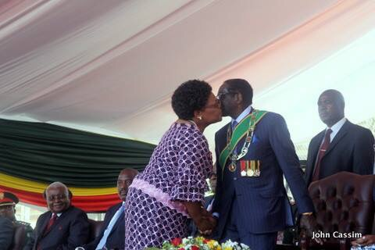

Image source @ Whatsapp images from data collection interviewee

The image shows the President of Zimbabwe as well as the head of the Zanu PF party, Robert Mugabe holding hands with the former Vice President ,Joyce Mujuru ,however the image circulated around social networks with the allegations that Robert Mugabe was having an affair with Joyce Mujuru, supported by the visual image which seems as if they were kissing .Accordingly the whole factionalism fiasco and the attacks of Grace Mugabe towards Joyce Mujuru was just a way to retaliate to Joyce Mujuru for having an affair with Grace Mugabe’s husband.

The image and its allegations symbolize defiance and the loss of respect for both Robert Mugabe and Joyce Mujuru and it also signals the manifestation of dissident amongst the citizens.

## News and implications about “Zanu PF on the ground” and “Zanu PF in central office”

## Robert Mugabe’s Capacity to lead

The capacity of Robert Mugabe to lead has been a debatable and highly criticized issue by both the local and international media. The media formalized the incapacity of Robert Mugabe to continue leading the party and the government when they brought the case into the newsroom because as Chouliaraki argues, media does more than just reporting news but it makes spectators feel that they operate generously on their own and are endowed with spontaneous civic or humanitarian feelings that makes them react. In other if the media is used unethically can create an uprising against the government or various authorities. Some of the critical news that posses the potential to nurture dissents is shown in the article below

*(CNN) U.S. Secretary of State Condoleezza Rice said the cholera outbreak that has killed nearly 600 people in Zimbabwe is the latest sign that President Robert Mugabe's rule over the country must end.*

*(France 24 news)Mugabe, a former liberation war hero who is Africa's third longest serving leader, is viewed with deep respect by many on the continent.*

*But he is also subject to travel bans from both the United States and European Union in protest at political violence and intimidation.*

*Mugabe, a former guerrilla leader who has ruled Zimbabwe since independence in 1980, is accused of crushing opponents to ensure his ZANU.PF party won every election for more than three decades.*

*(New Zimbabwe)Mugabe is a clever, brave and shrewd politician, a ‘wily old fox’ as some put it. But that is not sufficient to run a country, let alone one troubled with a battered economy, socio-political problems and other problems of all sorts. Running a country such as ours requires an energetic person, a person with less to worry about like health, brand issues and other issues that haunt Mugabe’s character. It needs a more forward looking person, simply put. Mugabe is no longer that guy. He is turning 90 on 21 February 2014. He is old and frail. It dictates from reason and common sense that given his immense contribution to the status quo, he must simply step down.*

## Robert Mugabe’s control over Zanu PF

*Perennial wisdom from divine revelation and human experience dictates that all earthly things great or small, beautiful or ugly, good or bad, sad or happy, foolish or wise must finally come to an end” ( Jonathan Moyo)*

Due to different factors and scandals that has wrecked Zanu PF during their sixth term, the media questions if Robert Mugabe is still a viable unifier and absolute leader over the party .Reeling under Norris (2010) idea of emphasizing the need to recognize media as an integral part of the core institutional framework that empowers a democracy, the press scrutinizes the ability of Mugabe to continue leading both Zanu PF and Zimbabwe at large.

## Zanu PF’s weakness

Mugabe’s endurance on the crown together with his generation of the 60s has now become a time bomb. The time bomb is expected to decimate 2018 or even later, Zanu PF has a lost generation, or even generations. Its corridors of power are filled with senior citizens who, in the fullness of time, will be phased out in a whisker. The party will be left with a serious power vacuum, having failed to invest in future leadership. Such is just the current leadership’s lack of foresight, a weakness for the organization. Again, the party has a serious deficit of brains, experience and capacity in the ages of 20-50. Very few young people have been allowed to rise in the echelons of power in the party.

*(New Zimbabwe )“the few young people in ZANU’s power corridors like Tabitha Kanengoni, Patrick Zhuwao, MuzendaJr etc. are relatives of top ZANU chefs even raises questions about whether they were recruited them on merit. And other young folks in the party have turned out to be self serving crooks and charlatans with nothing to offer. And Psychology Maziwisa? Sigh! ZANU’s only hope is on people like Walter Mzembi and uh ... No, Walter Mzembi only. There will therefore be a serious crisis in Zanu PF very soon, probably in the next 5 to 10 years, if nothing is done.”*

*(New Zimbabwe )“Everything comes to an end, and we must prepare for that by investing in the future if we wish continuation of the ideas we believe in. The party was supposed to open new avenues for new generations with fresh ideas. And Mugabe, at 90, could not get ministers in their 40 and 50s. He carried his generation along.”*

*(Zim eye)The spit.firing politician admitted to this party’s weakness, he was quoted saying he will work with Morgan Tsvangirai’s MDC.T. He said, “I would like to work with young people, like Chamisa (Nelson former MDC.T organising secretary) and Jessie Majome (Harare West lawmaker). They have brilliant ideas for the country, for the governance of the country which what we lack now,”*

## Robert Mugabe on Kamuzu Moments

In an argument on Robert Mugabe’s capacity to continue with the leadership of both Zane PF and Zimbabwe at large, the media has captured and criticized Mugabe’s embarrassing blunders and likened it to those that acted as the signals and symptoms of the brain and age exhaustion of the Malawian former President Kamuzu Banda.

* He made a damaging faux pas at the swearing in ceremony of his two deputies and 11 ministers at State House, he mistakenly referred to Vice President Phelekezela Mphoko as the new President. He said, “Photo is new president, vice president” before correcting himself.
* At the Zane PF congress, Mugabe shocked more than 12 000 delegates and millions watching live on television after he unwittingly denigrated his own party when he chanted a slogan, 'Pasine ZANU PF' which is an opposition party’s motto against Zane PF.
* This came after his wife 49.year.old wife Grace had ordered him off the podium using a handwritten note. After going through the note, 15 minutes later and seemingly having forgotten he was holding it, Mugabe appeared unsettled before announcing he had been ordered by the First Lady to close his speech. “My wife has written a note: she says I’m talking too much. That’s how I am treated even at home, so I must listen,” he chuckled before walking off the podium.
* Just before the congress, Mugabe suffered a serious lapse of concentration, damagingly blurting out that opposition leader Morgan Tsvangirai had garnered 73 percent of the disputed 2008 presidential vote. But minions of the country’s long ruling leader quickly cut in, forcing the nonagenarian to backtrack, claiming it was a slip of the tongue.
* Mugabe’s embarrassing faux pas was made as he addressed securocrats and war veterans at the Zanu PF headquarters. Before he was corrected, Mugabe admitted that he and Zanu PF had not done well in the 2008 elections; going on to say Tsvangirai had garnered 73 percent of the presidential vote in the plebiscite.
* “When we failed to win, when Tsvangirai got 73 percent of the votes …,” Mugabe said before he was forcefully interjected by some securocrats. “Oh, he got 47 percent of the votes and I got 43 percent,”

Nehanda radio claimed to have consulted a health expert on Mugabe’s scenario and accordingly: Health experts say half of people 85 and older have some dementia, usually Alzheimer’s. Dementia is a general term for a decline in mental ability severe enough to interfere with daily life. Memory loss and signs of dementia is an example and to Robert Mugabe that has been happening publicly and with worrying frequency

## CHAPTER TWO

## THE ROLE OF MEDIA IN THE ZANU PF’S INTRA PARTY CONFLICT

## STAGE 2: INTRA-PARTY CONFLICT

Intraparty conflict might take two forms namely intra elite conflict and elite follower conflict. Intra elite conflict is usually accompanied by elite follower conflict since members of the conflicting elites have their respective followers in the party organization. Yet, they are analytically distinct modes of conflict (Maor 1998, 11).

Intra-elite conflict is the conflict that occurs within the parliamentary party, including those between members of parliament and party representatives in government, whereas elite-follower conflict signifies any other internal disputes and amongst followers.

## The role of media in the Zanu PF’s intra elite and follower conflict

In the midst of political hiccups within the Zane PF party, the media played a crucial role in discrediting integrity, competence and allegiance to the party and de-campaigning Joyce Majuro, Didymium Mutes and their alleged members of the factionalist cadre.

## Social media

Whatsapp messenger as the dominant social network in Zimbabwe was an alternative press with no legal regulations to assess or censor the nature of information circulating on the internet, The extreme case of this network effect is that of a campaign item which 'goes viral', i.e. is distributed or seen by large numbers of social media users in a short period of time.

User produced content is not without risks user supplied content may end up muddying. Social media campaigns can encourage supporters to upload their own video and photo material about the candidate.

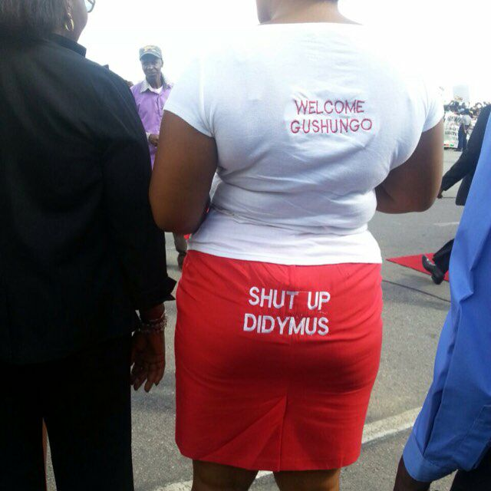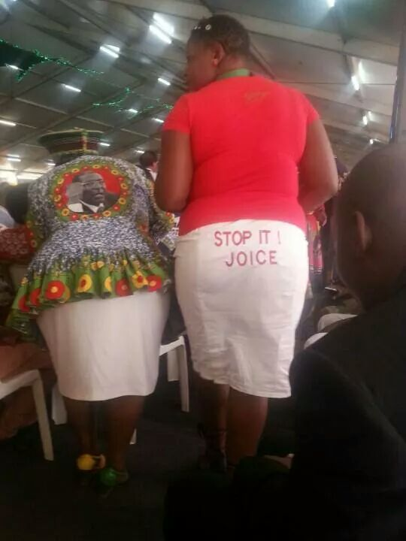

Image source @ Whatsapp images from data collection interviewee

The image shows decampagning content against the alleged two members of the factionalist cadre, Joyce Mujuru and Didymus Mutasa

In African traditional culture, the lower buttock region represents waste material because biologically that is where a human anatomy dismisses its waste materials. Extracting practical criticism from the images, Didymus Mutasa and Joyce Majuro are being likened to waste materials that have no use in the body( in this case the body represents Zane PF. On the other hand, the lady in the first picture is written “Welcome Gushing” on her back which portrays her support to Robert Mugabe and her readiness to sit upon the factionalists.

However, social media cannot replace face to face contact with the target population but can be a useful tool to deliberately direct political messages to certain target groups and personnel with offensive and derogatory context which can impact negatively on a person’s integrity.

I addition the social media conveyed the type of messages and content that is deemed unlawful due to its nature which is defamation of character. Whatsapp content posses all the main factors taken into account when assessing damages by the Zimbabwean legal society, in this regard most of the social network contents includes the following factors :

* The character and status of the plaintiff: a person with a good character and reputation will obviously attract greater damages than a person with poor character a person who is prominent and well known to the public will suffer greater harm to reputation than a person who is not a public figure.
* The nature of the words used and the intended effect thereof: the publication of a statement gravely maligning the plaintiff’s character will attract greater damages than an accusation of minor wrongdoing on the part of the plaintiff
* The extent of the publication: publication to a large number of people through a newspaper will cause greater harm than publication verbally to one other person
* Whether the statement was maliciously made
* Whether the defamatory statement was persisted in up to and during the trial of the action
* Whether the defendant has subsequently made attempts to rectify the harm done by way of a retraction or apology.

However due to the invincible nature of Whatsapp, inappropriate campaigning and decampagning materials which makes the victims eager to retaliate circulated on the internet without regulations, however ,since retaliation was not appropriate for Joyce Mujuru it only intensified the faction and friction within Zanu PF

## Voice

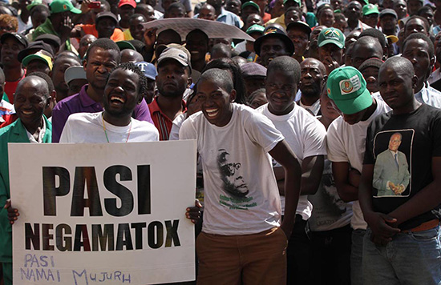

Image source @ www.pindula.com

Hirschman suggested that, dissatisfied members might leave the organization “exit”, or express their dissatisfaction directly to some authority “voice”, accordingly, voice is preferred to exit.

Out of twelve (12) ways to voice dissent proposed by (Dowsing, John, and Mergoupis 2000,), actors in the Zanu PF factionalism only used three (3) namely national congress motion ,vote of no confident and press release .However in the execution of all these ways to voice dissent the media was at the center breathing life into the phrase of voice.

## Press release

*(Zim eye)ZANU PF’s war against its members who are aligned to former Vice President Joyce Mujuru, who have been labeled gamatox, is far from over, with recent warnings from the Midlands spokesperson Cornelius Mupereri saying they will be fired. Addressing over 300 party leaders at a Kwekwe inter-district party meeting held Friday, Mupereri accused those aligned to Mujuru of being thieves, saying the party would not hesitate to fire them. BLESSED MHLANGA*

*(Zim eye) Expelled former ZANU PF Mash West boss and legislator Temba Mliswa, has vowed to destroy President Robert Mugabe’s authority in his constituency and before the 2018 elections, to form a powerful union with MDC.T leader Morgan Tsvangirai’s party.*

The media facilitates and generate a permanent wound and spirit of conflict; nothing ever seems to die because the media keeps records for future reference in the argument of criticism. Once a thread or conversation starts like Temba Mliswa claim to join to the opposition party there is no turning back even if his former party reconsiders his expulsion he will always poses as a threat to unity and a potential dissent to the party’s administration.

On the other hand, the media presented a balanced strategy by presenting the alleged factionalist side of the story, although it was veiled in obscurity due to the party’s healing, inauguration and appointment process of the new leaders to replace the dismissed party members that happened at the same time the alleged factionalist issued their press statement in defense of their competence and allegiance to the party. The media is credited for the balanced reporting

In contrast , the media did managed to present a balanced reporting for both factions ,but it does not change the fact that the media played a pivotal role in the factionalism of Zanu PF .according to the observation and focused group discussions conducted by the researcher as research instrument for data collection ,the researcher concluded that ,the balanced strategy by the media also reinforced the tension amongst Zanu PF factions because the expelled cadre issued a press statement with allegations of corruption in the party and they allegedly exposed the secrets and weaknesses of the party which is deemed as Zanu PF on the ground by the three face party model .Accordingly , the issues in the party on the ground are not suitable for publication because they do more harm than good to both the party and national political stability.

The press statement issued by the dismissed alleged Mujuru followers published issues of “party on the ground” The dismissed members of Zanu PF posed the following arguments against the Mnangagwa faction

1. Questionable Constitutionality of the so called “6th National People’s Congress” of December 2014.
2. Unprocedurally changes to the Constitution.
3. Unlawful and irregular “votes of no confidence”

* Lack of Democracy in the Zanu Party

According to our Party constitution, every member has a right to vote, and or be voted into any position according to Party guidelines. It is also common cause that the party has gone through unashamed violations and abuse of all the democratic tenets and common decency within the party. This has been eroded by dictatorship and personality cults created as a weapon to gain and “or retain power. One of the key values that motivated the liberation struggle was the aspect of “one man one vote”, which was denied the people of this country by the Late Ian Smith regime. This has been eroded and power has been centralized into a group of selfish individuals driven by greed and hate. Instead of fostering internal democracy as espoused in the ZANU (PF) founding principles, a clique emphasizing hate politics has overtaken the original principles of the party established right at the beginning of the struggle. This clique has introduced a sinister political culture of hatred, corruption, conflict, division, indiscipline, manipulation, and recklessness, which is the antithesis of the traditional democratic norms, and characteristic of ZANU (PF).

* Against Grace Mugabe's Ascendancy

We condemn the destructive pre-Congress rallies. The rallies leading to the so called “6th National People’s Congress” left a trail of destruction and division in the party. Outside the party and the country’s constitutions and any moral tenets, Amai Grace Mugabe went around the country preaching the gospel of hate in the presence of our very impressionable youths and the traumatized impoverished population. The following is worth mentioning:

* The Illegal Congress

In the build up to this illegal congress, it became clear that this clique of evil plotters had successfully waylaid Amai Grace Mugabe and Comrade Robert Gabriel Mugabe and started using them as weapons to unleash venomous and uncouth statements against anyone they perceived to be standing for the original ZANU (PF) values, ideals and ethos. As upright cadres of the revolution, we resolutely and patiently waited for the cardinal direction of our elected First Secretary and President of ZANU (PF), but his customary clear and unequivocal stance did not come until this undemocratic congress.

We strongly and regrettably bemoan the fact that this clique has robbed President R.G. Mugabe of his legacy as a unifier, a rational thinker and not only a national leader, but also one who inspired the region and the continent of Africa. After the 2014 whirlwind of legislation of mob rule, summarily expulsion of loyal members for perceived support of a sitting Vice President and as mentioned above, departure from the undisputable tenet of the liberation struggle – “one man one vote” to imposition of leaders, we now wonder how the nation, region and continent view our once revered President.

* Contesting the Congress Outcome

Illegitimate Outcome of the December Meeting) given the illegality of the so called congress, there is neither constitutional nor moral authority for it to form structures that can lead both the party and the government. We are therefore calling upon all loyal members and constitutionally elected leaders, to remain calm and promote peace as we pursue appropriate legal channels to reclaim the leadership of the party from the jaws of political vultures.

* On Nullification of the Congress Outcome

We are therefore calling for the legal nullification of the entire process of the so called congress as constitutionally flawed. Reinstatement of the entire constitutionally elected office bearers of the party in all structures of all wings, as at the 1st of July 2014. Nullification of all purported constitutional amendments drafted and rail roaded immediately before this socalled congress. Restoration of the elective dignity of congress and the one man one vote principle as enunciated by our armed struggle and constitution.

* Vote of No Confident and the National Congress Motion

During the course of the wave of change where the provinces were and other Zanu PF wings including the women’s league were pulling out the alleged factionalist relating to the Mujuru faction, the media balanced its coverage and made created an audible platform for both parties .Joyce Mujuru managed to defend her loyalty to the party and media including social networks was at the center of the process to present Joyce Mujuru side of the story to the nation.

On the other hand, the media did also played a pivotal role by providing a balanced reporting strategy during the course of the Zanu PF 6th national congress. Alleged factionalist did not attend the congress and the media made an effort to understand the gesture from the absentees of the congress though it was to no avail but the act portrays the sense of balance in media practice in as much as the coverage of Zanu PF factionalism is concerned.

To reinforce the unbiased reporting strategy presented by the media, it managed to present the alleged side of the story without distorting the messages and or judging the political gesture of defense, the article below portrays the press statement issued by the members of Zanu PF to the citizens of Zimbabwe.

*(Pindula.Com) Fellow Comrades and Friends) we are pleased to address you on behalf of all the loyal members of ZANU (PF) who are determined to restore the image of our party. Needless to say, this is a response to the unprecedented and destructive events before, during and after the socalled “6th National People’s Congress” held unconstitutionally in December 2014, the summary expulsions and suspensions of loyal members and the imposition of party leadership by one person, effectively abandoning the “one man one vote” that we fought for. This statement states our position and concerns and those of the members we are representing. We also make reference to the contents and substance of Cde D.N.E Mutasa’s letter to the SADC Chairman in which he asserted the following points” grievances)*

*Grievances*

*1. We are dismayed by the unlawful conduct leading up to and surrounding the purported congress*

*2. He indicated that we will remain married to the principles we fought for including, “one man one vote”, where majority rule prevails , which was not recognized in the recently unprocedurally amended ZANU PF constitution “adopted” at the illegal December meeting which masqueraded as a “Congress”. It gives all votes to the First Secretary and President alone and also violates the supreme law of the country. It is therefore, in the eyes of the majority of Zanu PF members, null and void along with all that transpired at and the purported resolutions at the so called “Congress”.*

*3. We call on ZANU PF to operate as it did before the so called 6th congress, which itself was unlawful.*

*4. We also appeal to all party members everywhere to remain peaceful as we strive for the democracy that we fought for.*

*5. This meeting was flawed, and held outside of Zanu PF own constitutional guidelines.*

*As loyal members of ZANU (PF), we agree with these points and further appeal to SADC to assist in resolving this crisis created by the socalled “congress” which continues to be a serious threat to the stability of ZANU (PF), Zimbabwe and the region at large.*

*Before we deal with the shortcomings and illegalities of the so called 6th National People’s Congress, we categorically refute and dismiss once and for all the allegations peddled by certain counter revolutionaries, that Amai Mujuru and others plotted to oust the First Secretary and President of Zanu Pf and the Republic of Zimbabwe, Comrade Robert Gabriel Mugabe from being President through assassination.*

## CHAPTER THREE

## THE ROLE OF MEDIA IN THE DEPARTURE AND SUSPENSION OF ZANU PF PARTY MEMBERS

## STAGE 3: EXIT

## Leader’s response

The final nail to the Zanu PF political instability ending with expulsion of the alleged factionalist cadre was at the top priority of media. Under the third stage, the media presented the issue to the audience with an open and balanced strategy.

However the members of Zane PF are not satisfied by the manner in which the press handled the whole Zane Pf fiasco .A Zane Pf official in Midlands Provincial office who have worked within the party for 32 year argued against the image painted by the media ,accordingly the media preached that Zane Pf has been divided into two factions namely Majuro and Mnangagwa faction , the Midlands Provincial Office dismissed the claims arguing that Zanu PF is not divided ,it is still one unitary and solid political party without any factions internal and external .Accordingly the party suspended and expelled Joyce Mujuru ,Rugare Gumbo ,Didymus Mutasa ,Temba Mliswa amongst other personnel on grounds of misconduct and failure to act in line with party structures in this regard there is no factions in Zanu Pf ,the party just removed people as it did before with Edgar Tekere.

Basing with the claims of Midlands Provincial Office, the researcher concluded that the media staged the existence of factions in the party, the media claims that Mujuru formed another Zanu Pf that will run against her former bosses however there is still no tangible evidence to those claims which means Zanu Pf is not divided however it just weaned unwanted members who were allegedly plotting to derail the party from its political and moral objectives.

## Media and the concept of Appearance and Reality

The concept of appearance and reality explains the complexity of political events and gestures; accordingly an event is interpreted under the scope of two aspects that is appearance and reality. Outward or visible aspect of a person or an event depends on the observers point of view, conditions preceding to his judgment and his attitude towards the incident ,in this regard different people deduce different meaning from the same incident or political gestures and no two people could share identical point of view with similar scope and trends ,that is the whole reason why there is consultancy firms in all fields of sciences ,commerce and arts faculties .On the other hand ,reality usually contradicts appearance ,Russels gives the example of a table ,accordingly ,to the naked eye ,the table appears to be smooth and hard .Aided by Microsoft ,the grain of the wood enlarges to appear as mountains range of different roughness and textures .Russels believes that the shape of the table ,a rectangle also changes as one walks around it and as one moves away from it.

By and large, political events display much controversies and traits of the theory of appearance and reality which presents the need for consultancy on political events. However basing on the data collected from herald provincial office, the provincial correspondents agreed that they do not always consult professional political scientists to interpret political events because the sole significance of media is to reflect the society, acting as a mirror to the audience and let the audience judge for themselves. Accordingly, the media is not responsible for the behavior of its audience after they read the news because the media does not tell the citizens what to do but it assist them in making well informed decisions.

The media literary misinformed its audience about the whole factionalism fiasco of Zanu Pf ,the media made people to believe that the party was divided into two, the Mujuru and Mnangagwa faction which it appears to be. An interviewee from the Zane Pf party dismissed the allegations of factionalism in the party ,accordingly ,the Zane Pf party is not divided in any way ,what the party did was dismissing certain former party members namely Juice Majuro ,Temba Melissa and Didymium Mutes just to mention a few. The politburo structured an internal committee that dealt with the alleged factionalist and the board proved that Juice Majuro and other cadres were misusing power and acting defiantly against party structures leading to their “expulsion from the party not division”. The interview who has worked for 30 years in the party gave reference to similar situations of Edgar Tekere. All in all, the party was not pleased with the way the media handled the political gestures in relation to Gamatox, the media made the audience to believe that Zanu Pf is now two folded which are baseless assumptions.

In defense of the media, the Herald correspondent of the Midlands Province argued that the media considers facts before they run the story .The factionalism in Zane Pf might not be in black and white as alluded by the Zane Pf Provincial office but the media gathered evidence through undisclosed sources which makes let them to believe that Juice Majuro was to establish a political party and run against Robert Mugabe.

By and large, the diction used by the media to define the whole Zane Pf fiasco misled the audience, evidently, though Didymium Mutasa claimed that Joice Mujuru was planning to establish her own political party that will run against Robert Mugabe, there is no tangible evidence to support those claims and there is no reason to rely on Didymus Mutasa because he is not JoiceMujurus spokesperson

Consequently, the media might not be literary telling its audience to take the law into their own hands but it is surely conditioning and generating the culture of defiance. As, Chouliaraki discusses in his theory of media influence , the media contents makes spectators feel that they operate generously on their own and are endowed with spontaneous civic or humanitarian feelings that makes them react. In this regard, there might not be factionalism within the Zane Pf party but there is now factionalism within the audience and supporters of Zanu Pf ,because the media made them to believe that Zanu Pf was now divided into two the Mujuru and Mnangagwa faction .

The seeds of factionalism planted by the media are gaining much momentum leading to political violence, hate speeches and serious divisions within the party. There were reports of violence as youths clashed due to factional differences. A group of youths accused a fellow youth leader Godwin Gomwe for humiliating the “provincial godfather” Didymus Mutasa and accusing him for agitating factional differences within the party. The Media Monitoring Project in Zimbabwe (MMPZ) supports the negative influence of media on human behavior, accordingly In Zimbabwe, hate speech has become a characteristic of some government officials’ language, and through the media an ultimate endemic and poisonous epidemic has negatively affected society through promoting extreme levels of political and social intolerance and hostility between groups and individuals.

In this regard the media has contributed more to the division of the Zanu Pf political party more than the alleged factionalist did.

## Research findings and conclusion

Significantly, this section’s discussion gives conclusion about the findings that were obtained from the data analysis that was carried out.

1. To analyze the impact and effect of media on human behavior

Media contents especially press release and internet sources greatly influences human behavior in different ways .For starters people believe in the old idiom that says “where there is smoke there is fire”, which means if a story or report manages to make news in the newspaper there is high probity that its authentic, therefore this makes the audience rely on news and believe in everything they read.

The data collection shows that, audience who are aged between 38-65 years based their judgment on a single newspaper article ,on the other hand the ages 65 and above don’t have interest in reading the newspaper and browse the internet for that matter because ,they regard buying newspapers as unnecessary expenses and 75percent of them have technological challenges of using computerized gadgets and the internet ,in this regard their source of information is Zanu PF rallies and news updates from Zanu PF members obliged to inform the party members especially the elderly. Only a few people read different newspapers and news sources for comparison and analysis.

According to the interviews, the media active generation is between 18-38 years; however this media active generation relies mostly on internet sources because they also deem buying newspaper copies as unnecessary expenses since they access any newspaper on the internet. The question under this generation is the authenticity and reliability of local news especially state owned media house like the Zimpapers ,people regard state owned media as biased and propaganda in favor of the ruling party so the audience resort to local independent media houses like alpha media house which owns Newsday amongst other papers ,international news station like France24 ,Press TV and BBC News are always their reliable source of information ,with the development of social networks and affordable internet bundles provided by telecommunication companies ,this generations spends 80percent of the internet time on social networks which also happen to offer news and updates as well as links to international news stations and local independent newspapers.

The interviews portrayed that media makes spectators feel that they operate liberally on their own and are endowed with spontaneous civic humanitarian feelings that makes them react which approves the Elizabeth Relms argument that the media when used unethically can be used to create an uprising against the government or various authorities.

2. To establish the relevance of media in managing political stability and instability

Media is the source of information in the 21stcentury, through the interviews the question proved not to relevance of media in managing political instability and or instability, but rather the authenticity and legitimacy of the source of information. The media divided its audience creating a culture of mistrust to certain media houses for example the state owned media is only a reliable source of media to people who are against Robert Mugabe’s administration, they claim that the major media house in which also a state owned entity lacks independence which makes Zimpapers products and services highly compromised and partisan in favor of Zanu PF

3. To establish the benefits and dangers of media on politics

Personal communication via social media managed to bring politicians and parties closer to their potential voters. It allows politicians to communicate faster and reach citizens in a more targeted manner and vice versa, without the intermediate role of mass media. Reactions, feedback, conversations and debates are generated online as well as support and participation for offline events. Messages posted to personal networks are multiplied when shared, which allow new audiences to be reached.

However, the interviews showed that, although the presence of social media is spreading and media use patterns are changing, online political engagement is largely restricted to people already active in politics and on the Internet. Other audiences are less responsive as discussed in the first objective. However the research proved that television news together with print and online newspapers are still the most important sources of political information in Zimbabwe.

4. To unearth the concept of situational appearance and reality

The concept of appearance and reality is still veiled in obscurity basing on the data acquired thorough the interviews. People makes their own political judgment using their political and moral believe, the use of political scientists and analyzed information is still not recognized

5. To make recommendations if they are any

In order to manage the problem of media ,although there has not a direct attempt to block or filter internet content but there is the Interception and Communications Act 2007 which allows the state to intercept messages deemed to be subversive on email, post and telephones. This act requires resources which the government might not afford but it can contribute significantly as a tool to manage unregulated media that can trigger political uncertainty

Accountability of political gestures by politicians, party members should be given a fair platform to be accountable for their actions regardless of their position or power in the hierarchy of politics .accountability might not be a panacea to the effect of media on politics or it will surely not end political violence and civil unrest but will make people to make informed decisions when embarking on a political activity

Regulated media should act as a yardstick to social networks ,it should interpret political activities with a professional opinion ,the Zimbabwe Broadcasting Cooperation should consider employing journalist and reporters who have knowledge and at least an honors degree in political science ,this will make their news more reliable .Political scientists cannot be involved on social networks so the regulated media should provide that platform of publishing professionally weaned political news to distinguish themselves from social networks.

## Conclusion

The main objective of this chapter which is the concluding chapter is to provide a summary of the research questions and objectives. In this researcher’s view, a focus on the role of media in the Zanu PF factionalism is an effort to unveil how the different forms of media managed to influence political parties and assist in the generation of political instability within the Zanu PF party and in Zimbabwe at large regardless of different legal regulative mechanism to control the power, influence and implications of media

Media freedom is essential in any reporting endeavor. It is not a privilege, but an obligation for media stakeholders to apply its use responsibly in the advancement of democracy and other human rights. Although Zimbabwean media enjoys wider freedom compared to other countries, political and commercial constraints hinder their independence and integrity. The manner in which the media participated in the Zanu PF factionalism generated and intensified deep seated national divisions. Various media houses took obvious positions for or against the political divide

This paper establishes that the media played a role in enhancing factions in the Zanu PF party as well as inspiring efforts to build transparency and good governance.

## BIBLIOGRAPHY

CNN NEWS, Rice) 'Well past time' for Mugabe's rule to end. December 5 2008 retrieved) 10 April 2015

DidymusMutasa responds to assassination plot claims, Harare 24News, Published) November 22, 2014, retrieved) April 13, 2015

Draft resolutions of Zanu.PF Congress, The Herald, Published) December 7, Retrieved) January 13, 2015

Data, Nabamita, Sueshna Pal and Sanjukta Roy (2011), “Media Freedom, Socio.Political Stability and Economic Growth,” Working Paper.

Elias Mambo Mugabe ‘mutilates’ Zanu PF constitution, The Independent, Published) November 28, 2014, Retrieved) January 14, 2015

Everson Mushava, Multimedia) Dump Mujuru – Grace tells Mugabe, Newsday, and Published) 17 Oct 2014, Retrieved) 7 Dec 2014

Freille, S. and Haque, E. and Kneller, R. (2007), “A Contribution to the Empirics of Press Freedom and Corruption,” European Journal of Political Economy, 23, 838.862.

Mugabe defends 'CdeGamatox', “Harare24”, Published) 31 Oct 2014, Retrieved) 14 April 2015

Mliswa and Chiyangwa Draw Daggers over Gamatox, “ZimEye”, Published) 15 Oct 2014, Retrieved) 14 April 2015

Mutasa and Mliswa expelled from ZANU PF, Nehanda Radio, and Published) February 18, 2015, retrieved) February 19, 2015

Members of Zanu PF statement to the citizens of Zimbabwe, Newsday, and Published) January 13, 2015, retrieved) March 13, 2015

Moses Matenga and FelunaNleya, Mugabe blasts VP Mujuru, Newsday, published) retrieved) 15 February 2015

P. Muzulu, Mugabe, and Newsday, published) 13 Jan 2015, retrieved) 13 march 2015”

Mike Dube ,Mliswa Vows to Destroy Robert Mugabe, and Unite with Tsvangirai, Zim eye, published) April 5, 2015, retrieved, 10 April 2015

Manhando, S. (1997) Broadcasting in a Deregulated Southern Africa. Zimbabwe’s Efforts to Engage with Technological Changes in Electronic Media, Department of Media and Communication, University of Oslo.

Norris, Pippa (2006), “The Role of the Free Press in Promoting Democratization, Good Governance and Human Development,” paper prepared for UNESCO World Press Freedom Day Meeting 2006.

Norris, Pippa and Dieter Zinnbauer (2002), “Giving Voice to the Voiceless – Good Governance, Human Development and Mass Communications,” Background Paper for Human Development Report 2002, UNDP.

Obey Manayiti, Mnangagwa leads faction not Mujuru, says Mutasa, “Southern Eye”, Published) 9 Jun 2014, Retrieved) 14 Jan 2015

President speaks against dividing Zanu PF, “ZBC”, Published) 6 Jun 2014, Retrieved) 14 Jan 2015

South Africa. Constitution of the Republic of South Africa, Act 108 of 1996.

Wendy Muperi Grace attacks on Mujuru hit new lows, Daily News, Published) November 19, 2014, retrieved) January 13, 2015

Tendai Mugabe VP Mujuru, Goche miss Politburo meeting, The Herald, and Published) November 27, 2014, retrieved) March 13, 2015

Video) Mugabe’s “PasineZanu PF” slogan shocks delegates, NewsDay, published) 8 Dec 2014, retrieved) 15 march 2015”

President blasts Prof Moyo, The Sunday Mail, Published) 7 June 2014, Retrieved) 8 June 2014

Obey Manayiti, Mnangagwa, Moyo divisive elements – Mutasa, Newsday, and Published) 9 June 2014, Retrieved) 6 Dec 2014

“The Janus faces of television in small countries. The case of Zimbabwe,” Critical Arts, 2, Durban.

Sage.Rusike, E.T.M. (1990) the Politics of the Mass Media.A Personal Experience, Harare) Roblaw Publisher.

Dutta, Nabamita and Sanjukta Roy (2009), “The Impact of Foreign Direct Investment on Press Freedom,” Kyklos, 62(2), 239.257

Dutta, Nabamita and Sanjukta Roy (2009), “What Attracts Foreign Direct Investment?A Closer Look,” Economic Affairs, 29 (3), 81.86.

Zanu PF Congress) 14 remarkable Mugabe &Dr Grace Quotes, Newsday, published) 8 Dec 2014, retrieved) 15 January 2015”

## APPENDICES

## Interview Schedule

DEMOGRAPHIC DATA OF RESPONDENT

Tick where appropriate

|  |
| --- |
|  |

|  |
| --- |
|  |

Gender: MALE FEMALE

|  |  |  |  |
| --- | --- | --- | --- |
| Age | Tick where appropriate | Working experience (years) | Tick where appropriate |
| 20 to 25 |  | 0 to 2 |  |
| 25 to 30 |  | 2 to 4 |  |
| 30 to 35 |  | 4 to 6 |  |
| 35 to 40 |  | 6 to 8 |  |
| 40 and above |  | 8 and above |  |

**QUESTIONS**

1. Do you know anything about ZANU PF’s factionalism?

YES ( ) NO ( )

***If yes,***

1. What do you know about ZANU PF’s factionalism

………………………………………………………………………………………………………………………………………………………………………………………………………………………………………………………………………………………………………………………………………………………………………………………………………

MEDIA HOUSE

1. Do you believe in the allegations against Joyce Mujuru and other factionalists?

YES ( ) NO ( )

1. What was the role media in the factionalism of ZANU PF
2. Constructive ( )
3. Destructive ( )
4. Mediator ( )
5. Informative ( )
6. Did your company consult a Professional Political Scientist to analyse political events relating to “gamatox” before publishing?

Yes ( ) No ( )

1. What do you consider in news to be deemed worthy printing?

..................................................................................................................................................................................................................................................................................................................................................................................................................................................................................................................................................................................................................................................................................................................

1. In your experience, would you say the media contributed to the demise of Joyce Mujuru?

YES ( ) NO ( )

If your answer is YES, can you explain HOW?

…………………………………………………………………………………………………………………………………………………………………………………………………………………………………………………………………………………………………………………………………………………………………………………………………………

1. Did the media provide a fair reporting platform for both factions ( Mujuru and Mnangagwa faction )

Yes ( ) no ( )

What do you think about the role of social networks (Whatsapp ,facebooketc) in the ZANU PF’s factionalism

…………………………………………………………………………………………………………………………………………………………………………………………………………………………………………………………………………………………………………………………………………………………………………………………………………

Can you comment on the news reported by international news stations (France 24 ,Presstvetc ) in regards to the factionalism of ZANU PF

........................................................................................................................................................................................................................................................................................................................................................................................................................................................................................................................................................................................................................

ZANU PF PARTY

1. What media sources did you use to inform party members about the factionalism in the party?

***NB: Tick where appropriate***

***: Tick as much as relevant***

|  |  |  |  |  |  |  |  |
| --- | --- | --- | --- | --- | --- | --- | --- |
| **Television news** |  | **Newspaper** | | **Internet** | | **Social networks** | |
| ZBC NEWS |  | HERALD |  | WEBSITES |  | WHATSAPP |  |
|  |  | NEWSDAY |  | BLOGS |  | FACEBOOK |  |
|  |  | KWAYEDZA |  | E-MAIL |  | TWITTER |  |
|  |  | CHRONICLES |  |  |  | YOUTUBE |  |

Other ……………………………………..

……………………………………..

………………………………………

1. What was the role media in the factionalism of ZANU PF
2. Constructive ( )
3. Destructive ( )
4. Mediator ( )
5. Informative ( )
6. Do you think the media in Zimbabwe provided a fair reporting platform for both factions

Yes ( ) No ( )

1. Were you satisfied by the news reported and the coverage made by the media?

YES ( ) NO ( )

-

1. Exposing the alleged factionalists through the media, how did you expect the audience to react?
2. Fight ( )
3. Accommodate ( )
4. Condemn ( )

Other..............................................

........................................................

1. Social networks have caused defamation of character amongst other crimes .What is your recommendation to the government in order to manage social networks?

........................................................................................................................................................................................................................................................................................................................................................................................................................................................................................................................................................................................................................................................................................................................................................................

1. Can you comment on the news reported by international news stations (France 24 ,Press tvetc ) in regards to the factionalism of Zanupf

........................................................................................................................................................................................................................................................................................................................................................................................................................................................................................................................................................................................................................

ZIMBABWE REPUBLIC POLICE

1. What do you think is the role of social networks (Whatsapp ,facebooketc) in the Zanu PF factionalism
2. Constructive ( )
3. Destructive ( )
4. Mediator ( )
5. Informative ( )
6. Social networks have caused defamation of character amongst other crimes .What is your recommendation to the government in order to manage social networks?

..................................................................................................................................................................................................................................................................................................................................................................................................................................................................................................................................................................................................................................................................................................................

PARTY SUPPORTERS

1. What were your source of information about the factionalism in Zanu PF

***NB: Tick where appropriate***

***: Tick as much as relevant***

|  |  |  |  |  |  |  |  |
| --- | --- | --- | --- | --- | --- | --- | --- |
| **Television news** |  | **Newspaper** | | **Internet** | | **Social networks** | |
| ZBC NEWS |  | HERALD |  | WEBSITES |  | WHATSAPP |  |
| SABC NEWS |  | NEWSDAY |  | BLOGS |  | FACEBOOK |  |
| FRANCE 24 |  | KWAYEDZA |  | E-MAIL |  | TWITTER |  |
|  |  | CHRONICLES |  |  |  | YOUTUBE |  |

Other ……………………………………..

……………………………………..

………………………………………

1. How often did you read political news relating to “gamatox”

Daily ( ) Weekly ( ) Monthly ( )

1. Do you trust your source of information on political news?

Yes ( ) No ( )

1. Did you experience or witnessed any violent action in relation to Zanu PF factionalism

Yes ( ) No ( )

If yes summarise the event

……………………………………………………………………………………………………………………………………………………………………………………………………………………………………………………………………………………………………………………………………………………………………………………………………………………………………………………………………..

1. In your experience, would you say the media contributed to the demise of Joyce Mujuru?

YES ( ) NO ( )

If your answer is YES, can you explain HOW?

…………………………………………………………………………………………………………………………………………………………………………………………………………………………………………………………………………………………………………………………………………………………………………………………………………

1. What did the media say about “gamatox”?

…………………………………………………………………………………………………………………………………………………………………………………………………………………………………………………………………………………………………………………………………………………………………………………………………………

## DATA COLLECTION LETTER

**Private Bag 9055**

**Gweru**

**Zimbabwe,**

**Telephone: +263-54-260450/260490/260409 Ext. 2159**



**POLITICS AND PUBLIC MANAGEMENT**

**MIDLANDS STATE UNIVERSITY**

18 February2015

Dear Sir/Madam

**SubjectUNDERGRADUTE DISSERTATION RESEARCH FOR ...............................................................**

This letter serves to inform you that the above named student is carrying out research as part of his fulfillment for undergraduate studies. The research topic reads: ................................................................................................................................................................................................................................................................................................................................................................................................................................................................................................................................................................................................................................................

For more information feel free to contact the Department.

Yours sincerely

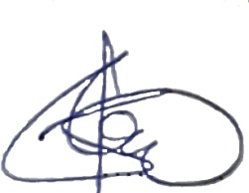

Prof PercyslageChigora

Chigorap2000@yahoo.com

**(Chairperson)**

**SUPERVISION CHECKING LIST**

**NB. THIS FORM MUST BE ATTACHED TO THE FINAL COPY OF YOUR DISSERTATION**

**NAME OF STUDENT.................................................REG no.........................................**

**STEP 1 LIASE WITH SUPERVISOR FOR TOPIC**

**SUPERVISOR............................................SIGNATURE..............................DATE..../..../....**

**Topic....................................................................................................................................................................................................................................................................................................................................................................................................................................................................................................................................................................................**

**STEP 2 SUBMIT TOPIC TO DISSERTATION COMMITTEE**

**CHAIRPERSON SIGNATURE..................................DATE...........................................**

**COMMITTEE COMMENTS........................................................................................................................................................................................................................................................................................................**

**Date of Approval........................................**

**STEP 3 SUBMISSION OF PROPOSAL**

**SUPERVISOR SIGNED.........................................DATE....................................................**

**STEP 4 DATA COLLECTION**

**Approved to proceed to data collection..............signed ................................date**

**STEP 5 PRESENTATION OF DATA FROM THE FIELD (RECORDINGS, QUESTIONNAIRES, INTERVIEWS.....)**

**SUPERVISOR.............................................SIGNED........................DATE........................**

**STEP 6 SUBMISSION OF THE DISSERTATION**

**SUPERVISOR ............................................SIGNED.....................DATE............................**

**STEP 7 SUBMISSION FOR VIVA-VOCE**

**CHAIRPERSONS................................DATE....................................................**